Joint-European-Forum IPCEI, Workgroup on Digital Brussels, July 15, 2024

Technology preview #1
“Draft on decentralised and federated infrastructure for artificial intelligence and services (AI)”
Disclaimer: This technology preview was drafted by the Working Group for Digital Technologies of the Joint European Forum for Important Projects of Common European Interest (JEF-IPCEI). The objective of this document is to contribute to the pre-screening whether certain technologies, infrastructures, value chains or sectors could possibly be suitable candidates for potential new IPCEIs. It should facilitate exchanges with representatives of industries and/or academia about potential IPCEIs in the pre-screened technology and/or infrastructure areas. This exchange does not prejudge whether an IPCEI will subsequently be pursued. It does not indicate a commitment, or approval by the participating Member States or by the European Commission on certain technologies, infrastructures or value chains, or an available budget and it does not bind any participant in this exchange. The numbering of the Technology previews does not reflect any prioritization or competition between the assessed technologies.
Machine Learning (Artificial Intelligence) is the key technology of our time and a paradigm shift apt to shape the next industrial revolution. It is essential for innovation, progress, the international competitiveness, and prosperity of the European Union. A new initiative in this field would result in a diversification of the computing resources available to European developers of foundation models and ease access to these resources in a decentralised and distributed way for all European industries, including SMEs. The initiative should strengthen the European Union’s ability to:
- Train foundation models: The objective of the initiative is the pre-competitive development of AI foundation models. Only such models can advance the development of AI applications in Europe at the necessary pace to ensure its digital sovereignty and competitiveness (Graph 1). The development of large Machine Learning models (aka foundation models), which provide the technological basis for multiple further developments and advanced applications is crucial for the European Union. The necessary foundation models developed pre-competitively will be made available to the public (as free and open source) in order to enable their broad application and integration for all European industries.
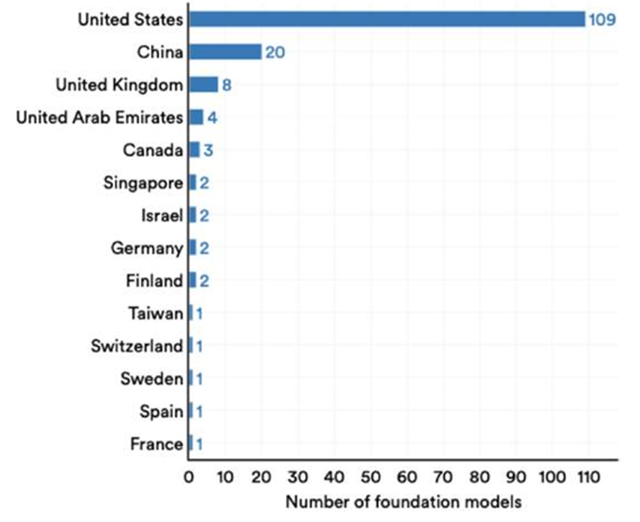
Graph 1: Number of foundation models by geographic area, 2023
(Source: Bommasani et al., 2023, Figure 1.3.18, AI Index Report 2024)
- Access and use sufficient computing capacity: A fundamental requirement for the research and development of these models is – beside suitable training data and AI experts – the availability of sufficient computing capacity in dedicated AI supercomputers or cloud computing, which is currently not sufficiently available to companies in Europe. The data storage and processing capacity required for training and deployment of AI is unprecedented. The underlying infrastructure must be optimized for handling AI workloads, notably at the level of data centre components like GPUs. This initiative aims to provide EU businesses, including SMEs, with access to the computing capacity needed to train and deploy foundation models. AI can only reach its full potential if the necessary hardware and software are in place to train and utilise AI models at scale. Inadequate access to software and infrastructure can lead to the emergence or the deepening of compute divides, limiting advances in productivity and negatively affecting competitiveness. The project would make the decentralized computing resources of AI technology in Europe (including test facilities) available to industries. This should also be achieved by promoting infrastructure providers and SMEs that develop advanced AI applications. The focus is on technology transfer to the economy to ensure that the developed foundation models are effectively put into practice and contribute to the economic performance of Member States on European scale.
- Perform coordinated research and development activities for foundation models across Europe: The initiative will enable Machine Learning-related use cases from the industry to be coordinated on European scale. This will contribute to developing either generative AI models, AI agents, multi-modal and predictive models, based on existing available data and with perspective to develop innovative solutions to meet the demand of the industry and academia (Graph 2). The training of foundation models in a federated, decentralised and distributed infrastructure needs further extensive research activities and is beyond the global state-of-the-art. In the current market environment, the operators of existing computing capacity in the EU do not have sufficient incentives to invest in necessary interconnection and compute capacities. Computing capacities should made available in a decentralised manner and distributed across Europe would constitute a first industrial deployment (FID). The initiative will create the necessary conditions for the development and application of AI foundation models and industry-related use cases at EU scale.
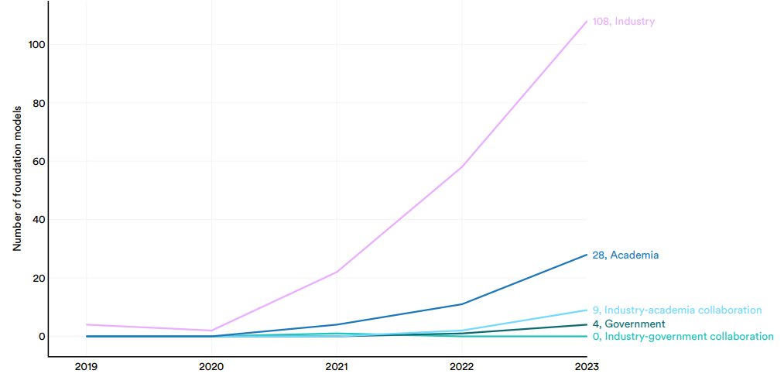
Graph 2: Number of foundation models by sector – global, 2019 - 2023
(Source: Bommasani et al., 2023, Figure 1.3.16, AI Index Report 2024)
The initiative will enable seamless interconnectedness and interoperability of different data spaces across Europe in order to contribute to the European leadership in the field of the digital transformation of the economy, showcasing through advanced AI applications and in convergence with WEB3 and WEB4 technologies, such as big data, digital twins, quantum computing, distributed ledger technologies and virtual solutions.
Advanced Use Cases to showcase the potential of the technology:
A significant impact of the AI foundation models is expected in the fields of manufacturing and robotics (Graph 2). By providing advanced capabilities in automation, predictive maintenance, and process optimization, these models can revolutionize manufacturing operations. AI-driven robotics can enhance precision, efficiency, and flexibility in production lines, leading to reduced costs and improved product quality. As an example, the integration of AI foundation models into robotics enables more sophisticated human-machine interactions, adaptive learning, and real-time decision-making, fostering innovation and driving the next wave of industrial automation. This transformative impact will not only bolster Europe's industrial capacity but also ensure that it remains at the forefront of global technological advancements.
Summary:
The Initiative pursues the objective of fully exploiting the innovation potential in AI as a key technology and sustainably strengthening the European economic structure through the joint development and provisioning of highly developed foundation models, as well as the creation of high qualified jobs, the promotion of SME and transfer of technology.

Source: https://aiindex.stanford.edu/wp-content/uploads/2024/04/HAI_2024_AI-Index-Report.pdf
Source: https://aiindex.stanford.edu/wp-content/uploads/2024/04/HAI_2024_AI-Index-Report.pdf

